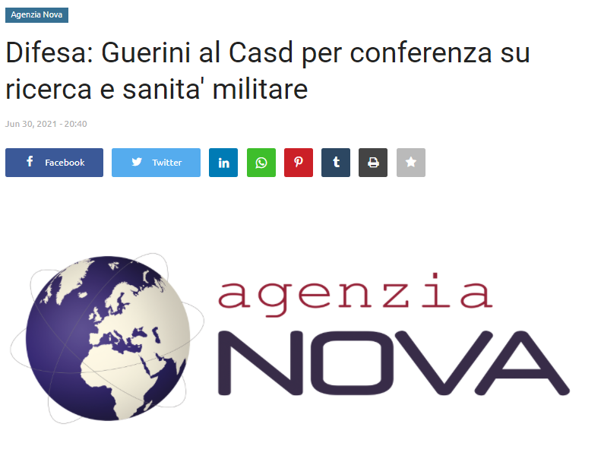
del Ministro della Difesa, Lorenzo Guerini, la conferenza scientifica su "Ricerca e sanita' militare: disruptive technology anti covid-19 dalla diagnostica precoce alla sicurezza degli ambienti". Secondo quanto riferisce una nota, il ministro, nel suo intervento, ha ricordato come, sin da inizio emergenza sanitaria, "tutte le Forze armate si sono messe in campo con grande impegno, disponibilita' e generosita' per aiutare il Paese nello sforzo collettivo che stava realizzando per fronteggiare l'emergenza. Credo - ha continuato il ministro - che il lavoro delle Forze Armate e del mondo militare si sia percepito sin da inizio emergenza. Non solo come ministro della Difesa ma anche come cittadino di una delle zone piu' colpite dall'emergenza Covid, ringrazio le Forze armate per il lavoro svolto e, in particolare, ringrazio il Comandante del Coi, generale Portolano, per lo splendido lavoro svolto garantendo nel contempo l'operativita' delle nostre articolazioni non solo negli scenari operativi dove siamo impegnati ma investendo, allo stesso tempo, sullo sforzo compiuto per contribuire alla lotta che il Paese stava svolgendo nei confronti dell'emergenza al Covid".
Nei suoi interventi, in apertura e chiusura dei lavori, il generale di corpo d'armata Carmine Masiello, sottocapo di Stato maggiore della Difesa, ha sottolineato come "l'evento odierno rappresenti un'ulteriore conferma della convergenza tra la societa' civile ed il mondo militare nel campo della ricerca e dell'innovazione nel settore sanitario. Questo approccio e' ancora piu' determinante oggi, ove il fare squadra assume priorita' assoluta dinanzi a scenari sempre piu' complessi". "Emerge, quindi, - ha sottolineato il generale - la necessita' di pensare in modo strutturato e sinergico, in ottica di sistema Paese, attraverso iniziative efficaci e coordinate, capaci di far fronte in modo sistemico al "bisogno di previsione", consapevoli che la prospettiva dell'anticipazione e' interdisciplinare e si fonda sul superamento di egoismi settoriali, oramai obsoleti e condannati dalla storia. Si impone, pertanto, l'esigenza di fare rete e di mettere a sistema le migliori risorse che il mondo militare, civile, industriale, dell'universita' e della ricerca hanno a disposizione, investendo sulla formazione, sulle competenze e sulla condivisione di idee".

La conferenza, moderata da Giuseppe Fioroni, consigliere del ministro della Difesa per la sanita' militare, ha visto la partecipazione di importanti rappresentanti militari quali l'ammiraglio di divisione Giacinto Ottaviani, nuovo presidente del Casd, il tenete generale Nicola Sebastiani, ispettore generale della sanita', il brigadiere generale Claudio Zanotto, supervisore farmaceutico della Difesa c/o Igesan e il brigadiere generale Florigio Lista, capo Dipartimento scientifico del Policlinico militare Celio. In particolare sono stati esposti i risultati delle sperimentazioni, condotte dal dipartimento Scientifico del Policlinico militare del Celio, sulle seguenti disruptive technology: la luce bianca della Biovitae con azione antivirale quale dispositivo led efficace nel controllo dell'infezione da SarsCoV2; la pittura Airlite come superfice attiva; la soluzione disinfettante Bioakt quale dispositivo medico-chirurgico per la sanificazione. Tutti i prodotti presentati, sono il frutto di tecnologia e sperimentazione italiana per un nuovo modo di combattere la pandemia, garantire la sicurezza degli ambienti e preservare la salute dell'uomo.
Nel suo intervento Sebastiani ha ringraziato gli operatori della sanita' militare e i colleghi, anche quelli reclutati recentemente, che hanno dimostrato competenza, generosita', coraggio e disponibilita'. L'Ispettore generale ha ringraziato il capo di Stato maggiore Difesa e tutte le autorita' militari, la Struttura Commissariale, il comandante del Coi e il ministro della Difesa per la lungimiranza e la determinazione dimostrata, che hanno permesso il miglioramento delle capacita' e delle strutture sanitarie militari, grazie alle risorse e al personale destinato. Rilevanti anche gli interventi del dottor Mauro Pantaleo, presidente Nextsense, dell'ingerner Massimo Bernardoni, co-fondatore e responsabile ricerca e sviluppo di Airlite e del professor Francesco Riva, consigliere del Consiglio nazionale economia e lavoro. (Com)

Link: https://rassegnastampa.news/difesa-guerini-al-casd-per-conferenza-su-ricerca-e-sanita-militare

